Name: Mpho Mugogovhali
3) Content Research and Sourcing
The Daily Grind Café Website
3.1) Organisation and Website
Located at 7 7th Ave., Melville, Johannesburg, South Africa, The Daily Grind Café is a fictional small bakery and coffee shop. The project scenario contained the website’s specifics. The Café’s name, business type, location, target market, mission statement, hours of operation, phone number, and email address are all included. Since this is a made-up company, there was no verified social media profile or official website from which to obtain content. As a result, some unique content made specifically for the website was combined with the client information supplied.
Students, freelancers, and locals are the target audience for this website. Every page’s content was shaped by this focus. It was designed to provide customers with all the information they require to determine whether to visit the café, including the menu, operating hours, location, contact details, and methods of contact. The mission statement is reflected in the site’s primary message: “To brew community, one cup at a time.”
Homepage Content (Index.html)

The daily Grind Café’s main introduction is found on the homepage. It includes the café’s name, mission statement, and a summary of its coffee and baked goods offerings, as well as a welcoming space for customers to work, relax, and socialize. Links that direct users to the Menu and Inquiry pages are also included on the homepage. To guarantee that important information is instantly available, these calls to action were created especially for this project. The goal of the hero section is to provide a brief overview of the café while leaving space for suitable image of the establishment.
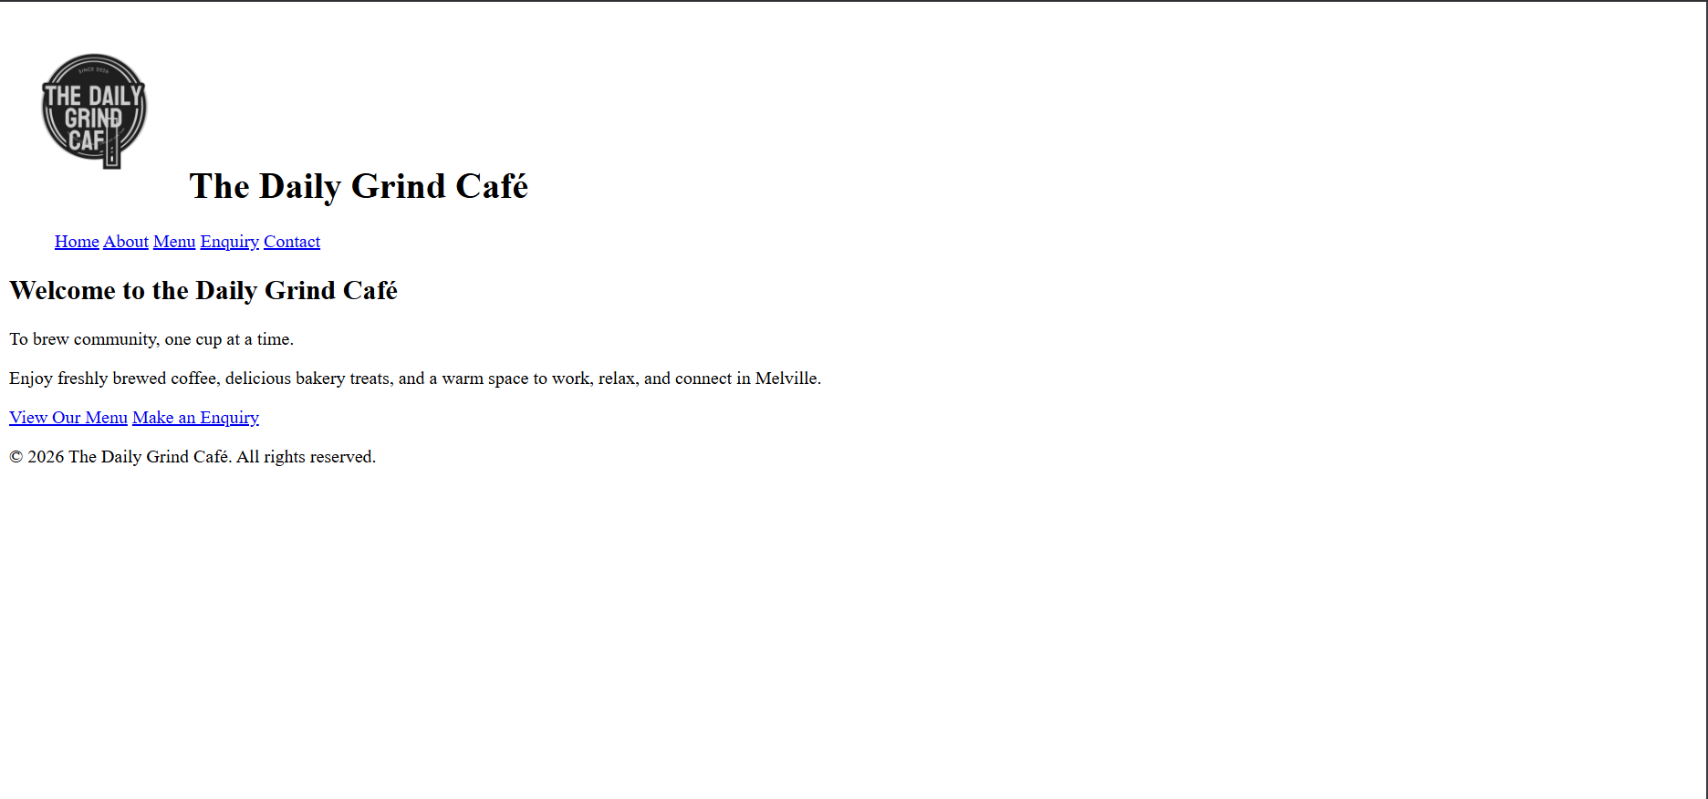
About Page Content (About.html)
The About page has original content that was created using the project scenario’s specifics. It describes the mission of the café and the sense of community it seeks to promote. The organization’s location, mission, and vision are covered in separate sections. The client’s information is the direct source of the mission statement. The additional mission and vision statements were written especially for the website to show how the café hopes to have a welcoming environment for locals, students, and freelancers. As a result, these descriptions are regarded as unique project content and are not taken from any external source.
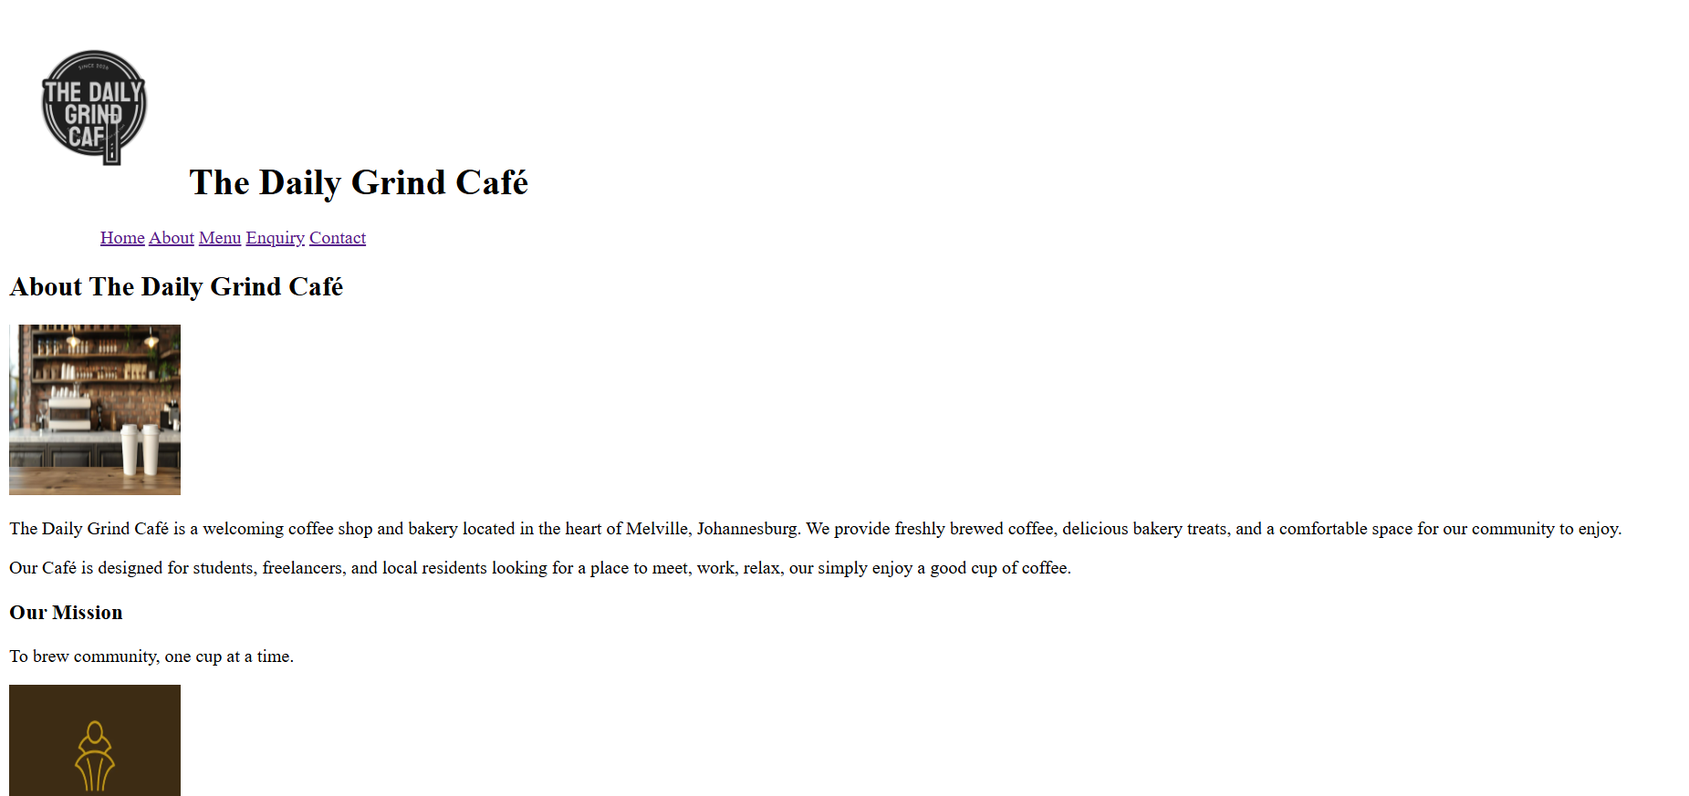

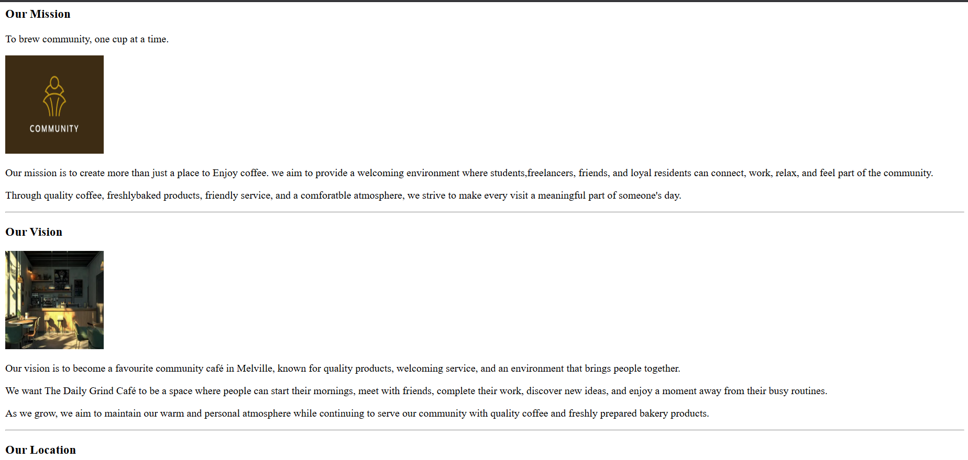

Menu Page Content (Menu.html)
Coffee and Light meals are the two primary categories on the menu page. Since the fictional organization did not have an actual menu, the particular menu items and their prices were created as original fictional content for this project. Drinks like espresso, americano, cappuccino, caffe latte, flat white, and mocha are available in the coffee section. Avocado toast, breakfast Sandwich, grilled Cheese Sandwich, and chicken & Salad Wrap are available for light meals. These products were picked because they fit the scenario’s description of the kind of business. Remember that they should not be interpreted as verified real-world goods or prices, but rather as recommended website content.
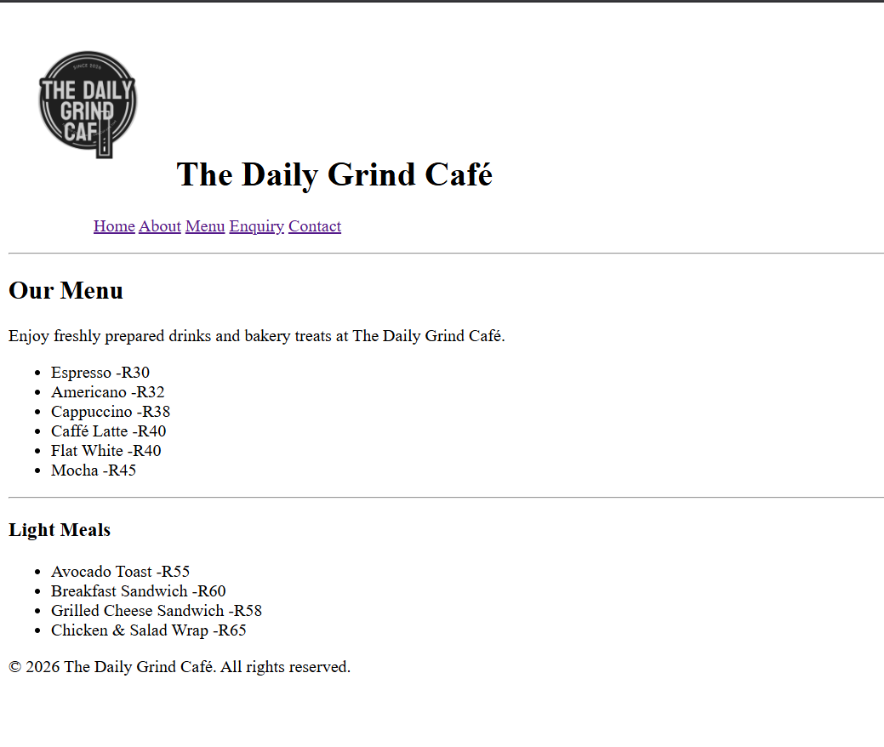
Enquiry Page Content (Enquiry.html)
To make it simple for customers to contact the café, the enquiry page was created. It collects the visitor’s message, email address, phone number, and type of inquiry. Booking requests, catering inquiries, general inquiries, and menu inquiries are different types of inquiries. These categories, which represent the kinds of information customers might desire from a small café, were especially designed for the project. A dropdown menu, a text area, and HTML5 form controls such as text, email, and phone inputs were used to organize the data. To reduce the number of incomplete submissions, required fields were added.
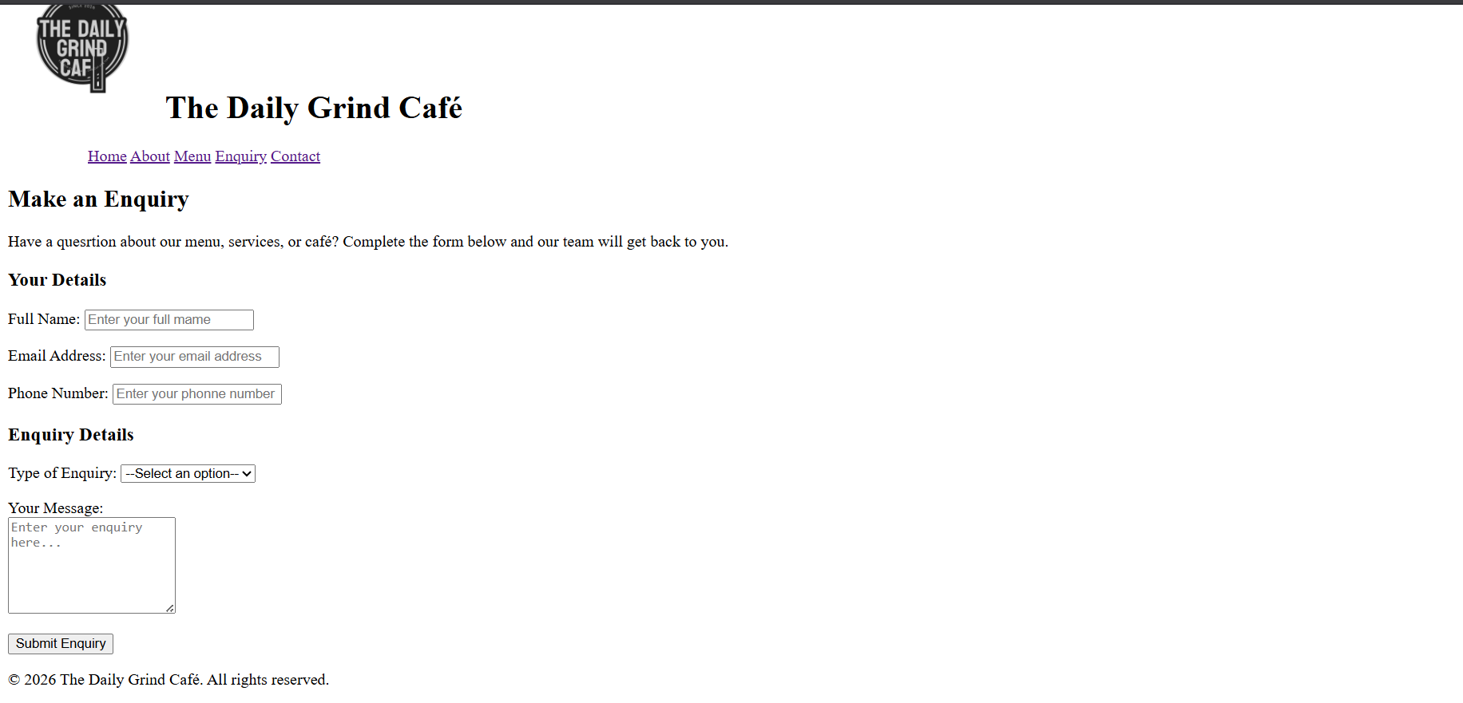
Contact Page Content (Contact.html)
The contact information supplied in the project scenario is displayed on the contact page. This includes the address, phone number, email address, and operating hours are 8:00 AM to 5:00 PM on Saturday and 7:00 AM to 6:00 PM on Monday through Friday. They can be contacted by phone on 011 555 1234 and through email at hello@thedailygrind.co.za. A google maps embed is also included on the page to help users locate the café. Therefore, the address information is not verified real-world business information; rather, it is part of the fictional client scenario.
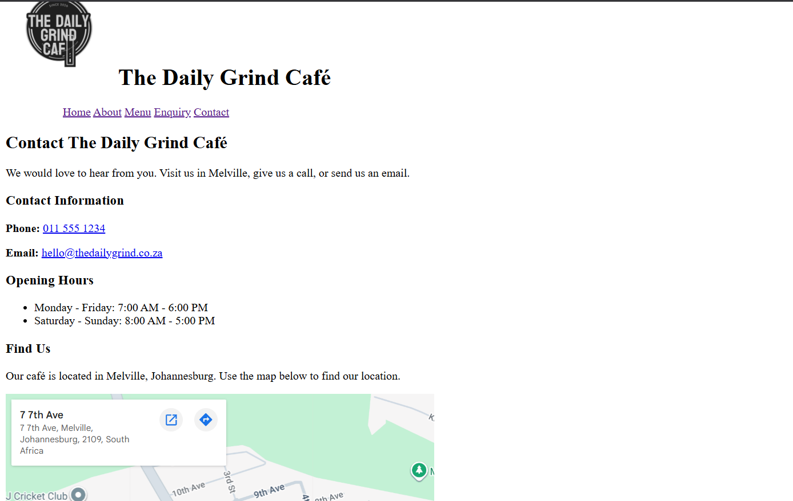
Logo and Original Content
An original project asset is The Daily Grind Cafe or using a third-party company logo. The menu descriptions, prices, vision statements, inquiry categories, and general descriptive text are examples of additional original content. Since the organization is fictional and there isn't a legitimate official website from which to obtain this information, creating original content makes sense.
File organisation
